**Laravel Installation and Folder Structure Assignment**

**Part 1: Laravel Installation**

I have using the below steps for Install the latest version of Laravel using Composer –

1. Goto targeted folder (here I use D:\ostadapp)
2. Open the command prompt ( D:\ostadapp> )
3. Run the below command –

*composer create-project laravel/laravel laraApp1*

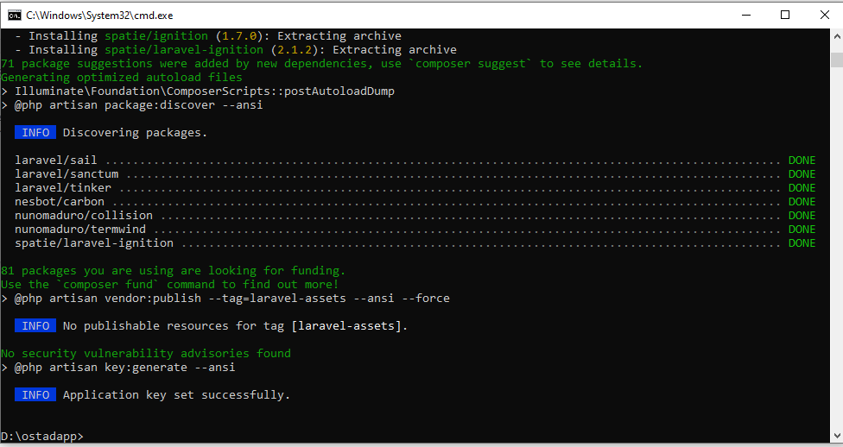

Verify that Laravel is installed and working correctly by creating a new Laravel project and running the development server.

1. D:\ostadapp> cd laraApp1 [ENTER]
2. 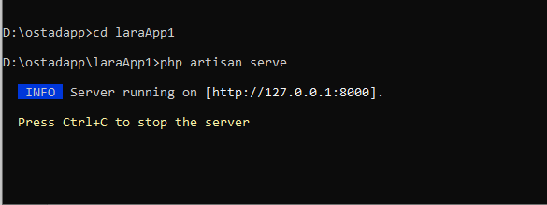D:\ostadapp\laraApp1> php artisan serve [ENTER]
3. Goto any browser and enter the below address in the browser address bar

<http://localhost:8000> or <http://127.0.0.1:8000>



1. If everything is ok then above screen will appear.

**Part 2: Laravel Folder Structure**

Describe the purpose of each of the following folders in a Laravel project –

1. **app** – This folder contains the core of the Laravel application, including the models, controllers, views, and other classes that define the application's functionality.
2. **bootstrap** – This folder contains the files that are responsible for bootstrapping the Laravel application. This includes the app.php file, which registers service providers, and the autoload.php file, which sets up the autoloading of the application’s classes.
3. **config** – This folder contains configuration files for the Laravel application, such as database connections, email settings, and other application-specific settings.
4. **database** – This folder contains the database migrations and seeders for the Laravel application, as well as any database-specific configuration files.
5. **public** – This folder contains the public-facing files of the Laravel application, such as the index.php file that serves as the entry point for the application, as well as any assets, such as images and stylesheets.
6. **resources** – This folder contains the resources that are used by the Laravel application, such as views, language files, and asset files like JavaScript and CSS.
7. **routes** – This folder contains the route definitions for the Laravel application, which map URLs to controllers or closures that handle the requests.
8. **storage** – This folder contains the application's storage files, such as logs, sessions, and cached views.
9. **tests** – This folder contains the automated tests for the Laravel application.
10. **vendor** – This folder contains the third-party packages that are installed by Composer, the PHP package manager. This includes the Laravel framework itself, as well as any other packages that the application depends on.

Here I have created a new route in my Laravel project (laraApp1) that displays a simple "**Hello, World!**" message. Below add screenshots of the running route –

